# Game Design

## High Concept

A first-person survival horror set in a village based off of the real world location of Nagoro, Japan AKA “The Scarecrow Village”. A western travel reporter arrives to do a piece on the village but come nightfall the village and its inhabitants take a sinister turn.

## Novel Design Features

The games key novel design feature is that it uses elements of Shintoism throughout the game, a key example being the use of Kuebiko in the game . The game takes place in an open world map with the whole village explorable as well as it’s individual buildings. The game also features multiple endings based on player choices.

## Mechanics

The game has four core mechanics those being:

* Stealth
* Resource management
* Puzzles
* Investigation/Exploration

The player will need to utilise the games stealth mechanics to avoid the patrolling enemies as the player moves throughout the village and its buildings. The player can use items to temporarily distract or stun the enemy. However, these items are limit and the player will have to carefully manage their resources or risk being left defenceless against the enemies of the game.

As the player explores the various locations of the game they will can across puzzles that need to be solved to get key items, used to open up more areas for investigation, or discover information that can help to unravel the mystery of the village.

## Narrative

The player is a western travel reporter sent, along with their cameraperson, to a piece on remote villages in Japan specifically “Kuebiko’s village” the village the game takes place in. after arriving at the village and being introduced to the inhabitants by the old woman that seems to be in charge of the village, the player and cameraperson go to stay in their lodgings. The player is awoken by a strange noise, the player goes to find their cameraperson only to discover they are missing. After some brief exploration in search on the missing cameraperson the player discovers that the cameraperson has been transformed into a scarecrow by the old women running the town and that they are coming to change her them into one next. The player attempts to flee the village but soon realises that they are trapped by a strange fog. The player is left with no choice but to find out what’s going on in this village and escape.

## Aesthetics

The aesthetics of the game will in general be focused on producing realistic looking environments. The village the game takes place will fit general patterns that can be observed in layout and architecture of traditional Japanese farming villages. A main village that inspiration will be drawn from in Nagoro. The environment outside of the village will be a mountainous and heavily forested area, this serves the purpose of keeping a realistic environment and also helps to build a sense of seclusion from the rest of the world. The reference images in the appendix can give a rough idea of how the village will look.

The aesthetics of the of enemies will intentionally lean into the uncanny valley to create a feeling of fear and discomfort in the player when they are confronted with both the enemies of the game and the other scarecrows littered throughout the village but remain inanimate. The reference images in the appendix can give a rough idea of how the scarecrows will look.

## Technology

The game will be made using some existing technologies such as unreal engine, unreal engine has been chosen because of the quality of graphics that can be achieved with the technology. The A.I. needed for the game will be bespoke, however, the A.I. will be quite simple its only functions will be to search for the player, purse the player when found and investigate distractions created by the player. The game will also utilise some simple physics used for some of the puzzles found throughout the village. The game will only have minimal UI to show the player how many distraction items they have and how much health & stamina they have left. The game will be rendered using deferred rendering to allow for the use of more dynamic lighting.

# Business Planning

## Market Analysis & Business Plan

This product will fall into the indie horror market with a target audience of 18+. The indie horror market is a highly saturated market so there is a risk of the game going unnoticed upon release due to the sheer volume of games on the market. The best way to mitigate these risks is to have a unique and interesting game as well as appropriate marketing to build awareness of the product both before and after release.

The product also entails some ethical issues that need to be carefully considered. The primary issues being how the culture and religion that inspired the game are portrayed in the game. Careful consideration needs to be taken when using these certain aspects to avoid any offense or appropriation of the culture and religion that is in the game. Another ethical issue to be considered is IPR and copyright. Since the scarecrows of the game are based off the real artwork of somebody there is a possibility that those artworks are copyrighted, to avoid these issues the scarecrows used for the game will need to be distinctly different from the source material. The IPR and copyright of any assets that are used for the product that are not wholly ours need to be handled appropriately with proper credit given.

The development costing requires some assumptions to be made. The assumptions being that the team size is 6 developers working for about £12/hour and the total time for development being 275 hours. These assumptions result in £19,800 in cost for payment of developers. An average indie marketing campaign costs around £50,000 however due to the saturation of the market a slightly larger campaign will be required. An estimate for marketing campaign cost should be around £80,000. An additional £2,000 should be included for any assets or software that may need to be licenced. This totals at £101,800 development cost. With the game being the first release for the developers an aim of 10,000 units sold would be the goal. So, to make back development costs the game would need to be sold for a minimum of £10.18. To make a profit from the game it would be best to aim for a price per unit of £12.99 resulting in an overall profit of £28,100 if the target of 10,000 units is sold.

## Development Schedule & Project Management Plan

Below you can find the development plan for the game demo given a team of 6 and 275 hours of development time. In the appendix you can find the Gantt chart that visualises this plan.



# Appendix

**Village References:**

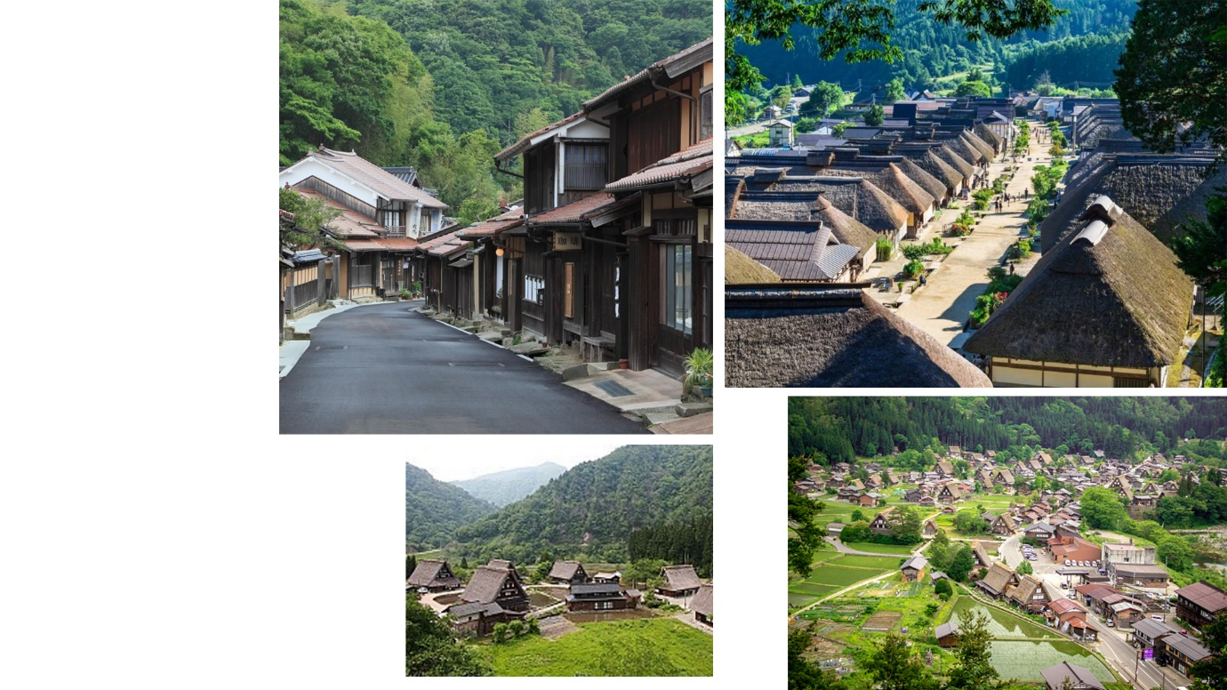

(Travel, n.d.) (Guide, n.d.) (Jones, 2019) (fernofarch, 2016)

**Scarecrow References:**

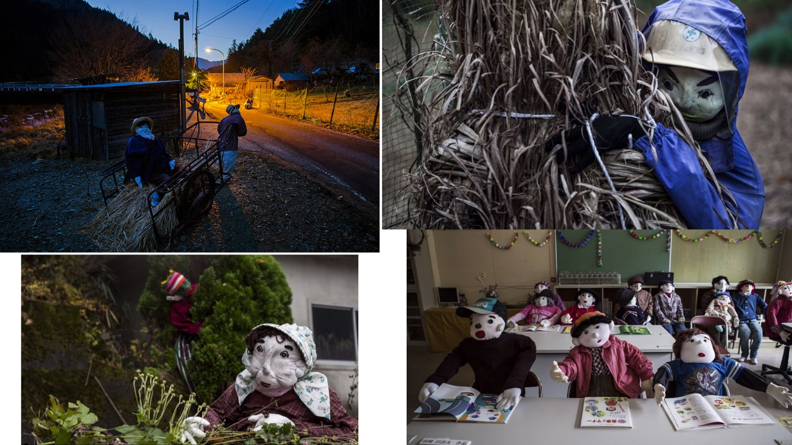

(Grundhauser, 2015) (Souppoutis & Schumann, 2014)

**Gantt Chart:** On Following Page

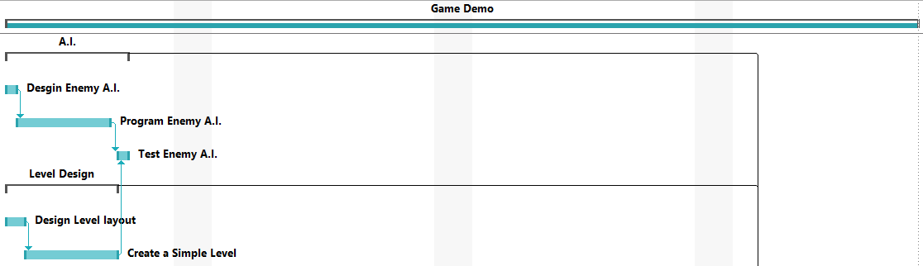

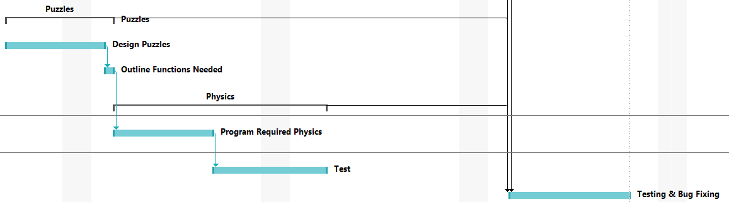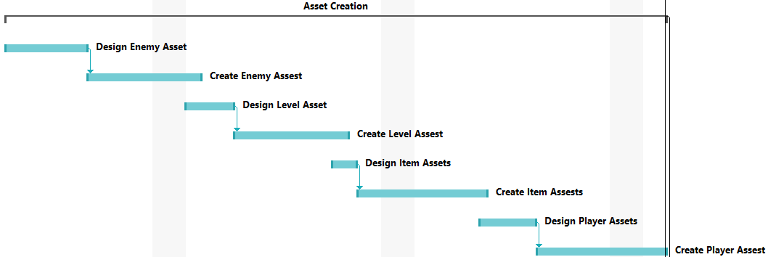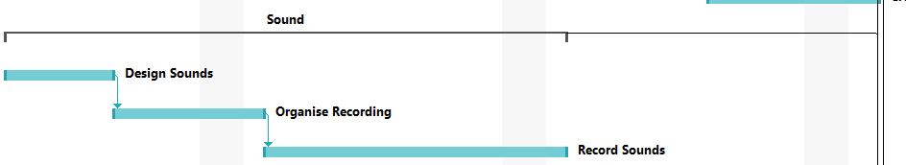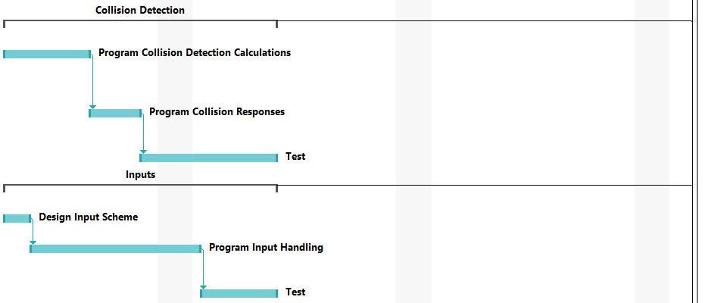

# References

fernofarch, 2016. *iStock - Old Japanese Village Birdseye view stock photo.* [Online]   
Available at: https://www.istockphoto.com/photo/old-japanese-village-birdseye-view-gm510152508-86118949

Grundhauser, E., 2015. *Toys Are Us: The Japanese Village Where Dolls Outnumber People.* [Online]   
Available at: http://www.slate.com/blogs/atlas_obscura/2015/03/23/japan_s_nagoro_village_is_mainly_populated_with_dolls.html

Guide, J., n.d. *Farming Towns.* [Online]   
Available at: https://www.japan-guide.com/e/e2422.html

Jones, M., 2019. *A new take on old Japan – that's Omori.* [Online]   
Available at: https://www.theguardian.com/travel/2019/sep/15/omori-village-hiroshima-japan-sustainable-traditional-abeke-gungendo-shibusa

Souppoutis, A. & Schumann, F., 2014. *EXPLORE THE HIDDEN JAPANESE VILLAGE WHERE DOLLS REPLACE THE DEPARTED.* [Online]   
Available at: https://www.theverge.com/2014/5/2/5674448/nagoro-japanese-doll-village-photos-video

Travel, B. i., n.d. *10 AMAZINGLY BEAUTIFUL SMALL VILLAGES IN JAPAN.* [Online]   
Available at: https://breathintravel.com/small-villages-in-japan/